Summer Project report on

P-N-C GROUP (A Family Business Website)

by

Amey Dileep Chousalkar

Hitesh Kumar Choudhary

Under the guidance of
Internal Supervisor
Aarti Karande

Department of Master in Computer Applications
Sardar Patel Institute of Technology
University of Mumbai
2016-17

CERTIFICATE OF APPROVAL

This is to certify that the following students

Amey Dileep Chousalkar

Hitesh Kumar Choudhary

Have satisfactorily carried out work on the project entitled
“P-N-C GROUP (A Family Business Website)”
Towards the fulfillment of summer project, as laid down by University of Mumbai during year 2016-17.

Project Guide

PROJECT APPROVAL CERTIFICATE

This is to certify that the following students

Amey Dileep Chousalkar

Hitesh Kumar Choudhary

Have successfully completed the Project report on “P-N-C GROUP (A Family Business Website)”, which is found to be satisfactory and is approved

At

SARDAR PATEL INSTITUTE OF TECHNOLOGY,
ANDHERI (W), MUMBAI.

INTERNAL EXAMINER EXTERNAL EXAMINER

Head of Department Principal

Table of contents
Abstract
The Print-N-Coat Organization was established in the year 1978. We are a force to reckon with in the field in manufacturing form many Years. Serving the needs of diverse industries. We continuously diversify to meet new horizons and challenges with competence and dynamism. We responded by expanding our product line Our Plant is having all the machinery to manufacture all products.

SCOPE OF PROJECT
The P-N-C Group is a Manufacturing Industries. This website provides the information about company, their products - ultimately helping the customers expand to meet their mission. As more and more individuals respond to the growing needs for the future growth of company
This website helps to find the customer needs in our day to day of finding Printing Inks, Paints, BOPP Tape, Corrugated Boxes and Grape Guard Paper. All you have to do is to go on contact page on the website and fill up all details required. We’d give you the best product & quality according to your requirement.
We always keep a good relationship with out clients and we distribute a good quality of products so our clients are also very happy so that way we keep the tag line of our company is “MANUFACTURING RELATIONSHIP. DISTRIBUTING QUALITY”
DESCRIPTION
The Print-N-Coat Organization was established in the year 1978. We are a force to reckon with in the field in manufacturing form many Years. Serving the needs of diverse industries. We continuously diversify to meet new horizons and challenges with competence and dynamism. We responded by expanding our product line Our Plant is having all the machinery to manufacture all products.
Our Slogan:
MANUFACTURING RELATIONSHIP. DISTRIBUTING QUALITY

NEETA INKS
Manufactures of Products like printing inks offset inks & Decorative Paint. These innovations have been made in the formulation of Offset or “paste” inks over years, keeping pace with the evolutions that have marked the Graphic Industry. The appearance of high technology printing equipment with faster and faster printing speeds, requiring inks with excellent printing stability.A diversification in the range of printed substrates (recycled paper, more varied synthetic substrates, etc.) requiring more and more versatile inks. An evolution in environmental legislation (VOC emissions, recycling of packaging, etc.).To get to know these inks better, we propose to cover the following points:
Ink is paste that contains pigments or dyes and is used to color a surface to produce an image, text, or design. Thicker inks, in paste form, are used extensively in Offset printing.
Ink can be a complex medium, composed of solvents, pigments, dyes, resins, lubricants, solubilizes, surfactants, matter, fluorescents, and other materials. The components of inks serve many purposes; the ink’s carrier, colorants, and other additives affect the flow and thickness of the ink and its appearance when dry.
PNC PAINTS
PNC Paints is a leading industrial paint and decorative paint manufacturing company based in The Decorative paint products include exterior wall finishes, interior wall & wood finishes and enamels. PNC Paints has always been a front runner in introducing new ideas like Kids’ World, Colour Worlds, Colour Next and Home Solutions. Their varied product range includes decorative paints, industrial coating, and waterproofing and wall putty. We products for home, house painting, wall painting etc. Its innovative and eco-friendly product range includes decorative paints, Marine coatings, Industrial coatings, automotive coatings and fine chemicals.
MAYURI PACKERS & PRINTERS
Corrugated Boxes and BOPP Self Adhesive Tapes. We are manufacturing corrugated boxes since from 2005. Serving the needs of diverse industries, our Wax coated Paper & Laminated Paper.Manufacturing flexible packaging & BOPP Self-adhesive tape. BOPP tapes ideal Usage for sealing all types of export Cartons. Resistant to ageing, UV lights, Moisture and even extremes of temperature. We specialized in offering a wide range of Packaging tapes such as Self Adhesive Paper tape, Self Adhesive Plain BOPP tape & Self Adhesive printed BOPP tape to meet customer and industry most unique requirements. Our customer base includes companies in a variety of industries which include Bonding, Pasting, Packaging, Branding industry and commercial.
Our Plant is having all the machinery to manufacture Quality corrugated boxes –
- 52” High Speed Corrugated Machine Narrow Flute.
- Pasting Machine 62” & 85”
- Cutting Machine
- Rotary Creaser
- Combined Slotter & Cutter (Imported China Make) RS4
- Punching Machine
- Stitching Machine 36” & 48”
- Strapping Machine

Our vendor list includes

1. Bedse Pulp & Paper Conversion Pvt. Ltd.
2. Bedse Paper Pvt.Ltd
3. Kaygaon Paper Mills Ltd.,
4. Vishwa Paper Mills.
5. Gajanan Paper Mills Pvt Ltd.
6. Umesh Papers Pvt. Ltd.
7. Harisharnam Trade links Pvt.Ltd.
8. Ajit Paper Mill
9. Vaishnavi Papers.

Our vendors are selected on the basis of manufacturing capacity, vicinity to our plant, capability to meet our requirement and reputation in the market.

We supply our quality product to the following Clients –
- Allied Blenders & Distillers Pvt.Ltd
- Pernod Richard India Pvt. Ltd
- Radico NV Distilleries Mah. Ltd.
- Varsha Plastic Pvt. Ltd.
- Specialty Polyfilms(I) Pvt.Ltd.
- Flexicut Abrasive Pvt. Ltd.
- Akar Tools Ltd.
- Ravalgaon Chocolates
- Khadkeshwara Hatcheries Pvt. Ltd.

MEGHA INDUSTRIES
Manufacturer of Corrugated Boxes. Corrugated paper board containers are extensively used in the packaging of industrial as well as consumer goods Corrugated box design is the process of matching design factors for corrugated fibreboard boxes with the functional physical, processing and end-use requirements. Packaging engineers work to meet the performance requirements of a box while controlling total costs throughout the system. Serving the needs of diverse industries, our Wax coated Paper, Laminated Paper & Corrugated boxes.
We responded by expanding our product line to include BOPP Self Adhesive Tapes.
We have started manufacturing BOPP Self Adhesive Tapes in 2009, and recently started with Surface Protective Film.
Our Plant is having all the machinery to manufacture Quality BOPP Self Adhesive Tape :
- Coating Machine
- Slitting Machine
- Core Cutting Machine
- Table Top (Slitting) Machine.
- Four Colour Rotogravure Machine
- Single Colour Rotogravure Machine
- Weighing Machine.
Existing conversion of ours is Approx. 800 Boxes Per Month.
Conversion capacity of our Plant is Around 1500 Boxes Per month.
We are well known in manufacturing BOPP Self Adhesive Tape as per customer Requirements/Specifications in terms of Printing, Microns & Length.

Our vendor list includes
1. Cosmo Films Pvt.Ltd.
2. Garware Polyster Ltd.
3. Jeasons Industries Ltd.
3. Pidilite India Pvt.Ltd
4. Venus Industries.
5. Megha Industries.
Our vendors are selected on the basis of manufacturing capacity, vicinity to our plant, capability to meet our requirement and reputation in the market.
We supply our Major quality product to the following Clients –

FMCG
- ITC India Ltd

Liquor
- SAB Miller India Limited.
- Allied Blenders & Distillers Pvt. Ltd.
- Radico NV Distilleries Mah. Ltd.
- Hindustan Distillaries Pvt.Ltd.

Plastic and Moulding
- Garware Polyester Ltd.
- Dream Plast India Pvt. Ltd.
- Aurangabad Polycontainer Pvt. Ltd.
- Varsha Plastic Pvt.Ltd
Food Industries
- Frigorifico Alana Limited
- Radiant Indus chem Pvt Ltd.
- Alana Sons Limited
- Trimurti Foodtech Pvt. Ltd.

Pharmaceutical
- Ajantha Pharma Limited
- Midas Care Pharmaceutical Pvt. Ltd.
- Harmon Finochem Limited.
- Harsh Vaibhav Pvt. Ltd.

Engineering and Others
- Franke Faber India Limited
- Akar Tools Limited
- Morganite Crucible(India)Limited

AJANTHA CHEM PRODUCTS
We are a force to reckon with in the field of Grape guard paper since 15 years.
We responded by expanding our product line to slow release and fast realise grape guard
Grape Guard Paper (SO2 Release Paper) It is use to increase life of grapes while transportation. Grapes are harvested in the months of January – March when the ambient temperature varies from 25 –32^0 C with a relative humidity of 40-80 per cent shapes and sizes, ventilated CFB boxes. For packing in CFB boxes, prepare a layer of paper shreds as cushioning at the bottom of the polythene bag, placed in the CFB box.
Grape guard is a sheet of paper available in 2 forms.
(I) quick release or with a layer of sodium bisulphite coated on one side of the paper
(II) the slow release (SR) has the coating as QR with small white pouches with granules of sodium bisulphite packed in it. When the grapes are packed in polythene bags, they are held at low temperature.
Objectives
List of figures

List of tables

- Introduction
  - Problem Definition
  - Objective & Scope
  - Existing System
  - Proposed System
  - System Requirements
- Literature Survey
This is comprise the details of all other work done so far in this area and what are the problem faces what are the approaches used to solve it and what are all the issues raised
- Software Requirement Specification[SRS] & Design
  - Introduction
    - Purpose
    - Definitions
    - System overview
  - Overall description
    - Product functions
    - User characteristics
  - Specific requirements
    - External interface requirements (if any)
    - Functional requirements(if any)
    - Performance requirements(if any)
    - Logical database requirement(if any)
    - Software System attributes(if any)
    - Other requirements(if any)
- Project Analysis and Design
  - Methodologies Adapted
    - Detailed life Cycle of the Project
  - Modules
4.2 UML Diagram
4.2.1 Use Case Diagram with Report
  - Architectural Design
  - Database Schema/ Design
    - E-R diagram
(Contact Page)

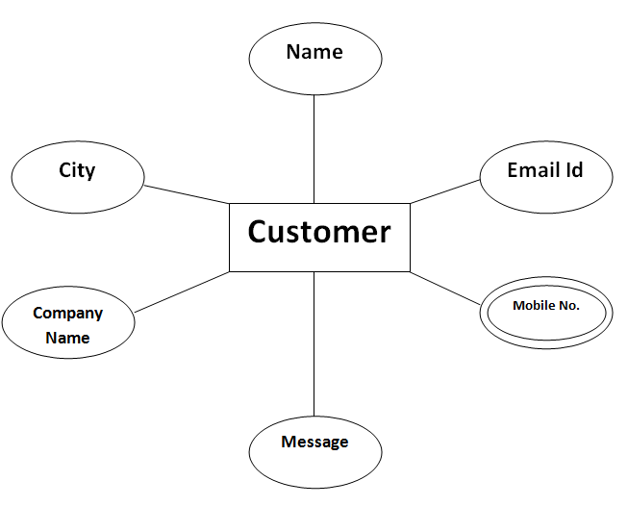
Order Now Page

ORDER NOW

IMAGE
QUANTITY
PRODUCT

ADDRESS
NAME

CUSTOMER

CONTACT NO
EMAIL ID
PAYMENT

ID
CARD NO.

EXPIRY DATE
CVC

    - DFD diagram
    - Database schema design

TABLE DESCRIPTION

CONTACT

Sr. No. | Column Name | Data Type
1 | Name | VarChar(20)
2 | Email Id | Text
3 | Mobile No. | Int(10)
4 | Company Name | Text
5 | City | Text
6 | Message | Text

ORDER NOW

Sr No. | Column Name | Data Type
1 | Id | Int(4)
2 | Quantity | Int(4)
3 | Image | Varchar(30)
4 | Name | Varchar(50)
5 | Email id | Varchar(50)
6 | Number | Varchar(30)
7 | Address | Varchar(100)
8 | Card no. | Varchar(50)
9 | Expiry Date | Varchar(50)
10 | CVC | Int (30)
11 | Price | Int(5)

5. Project Implementation & Testing
5.1 Work Break Down Structure
5.2 Gantt Chart
5.3 Pert Chart and PERT Table
5.4 Time Line
5.6 Code with reference to design

5.7 Snapshot of UI & Reports
SCREEN SHOTS

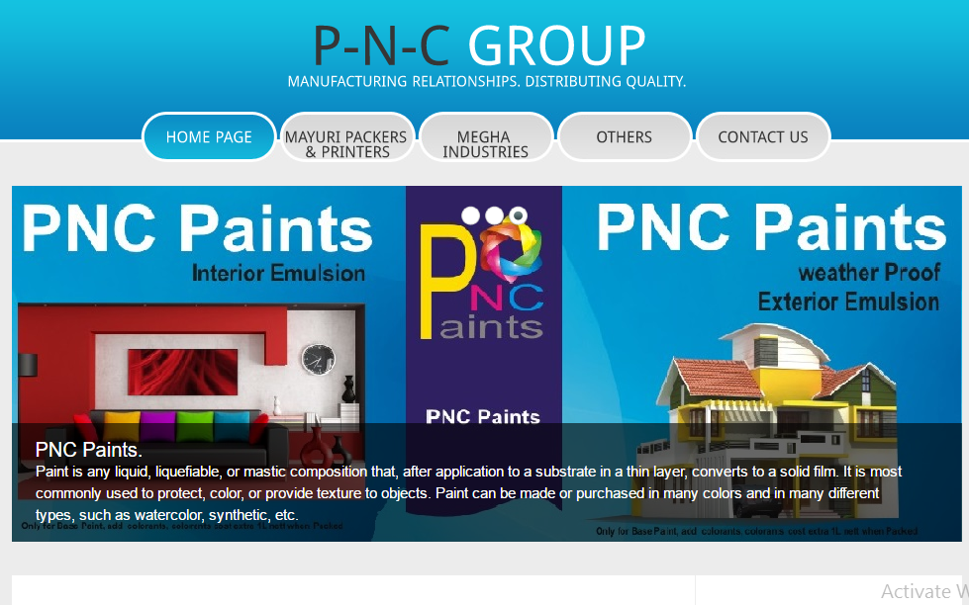

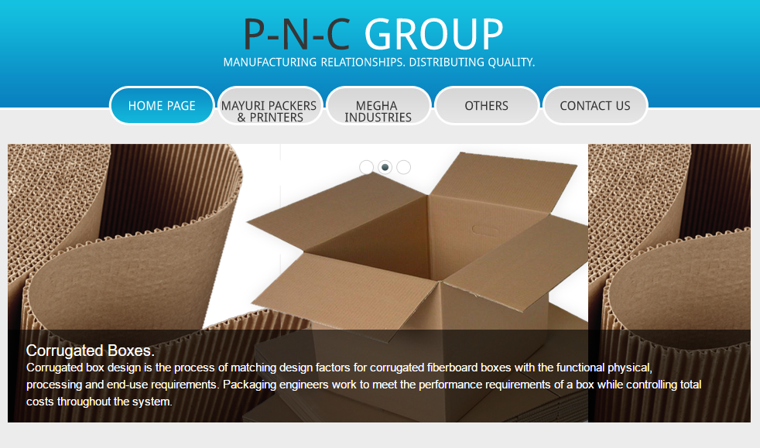

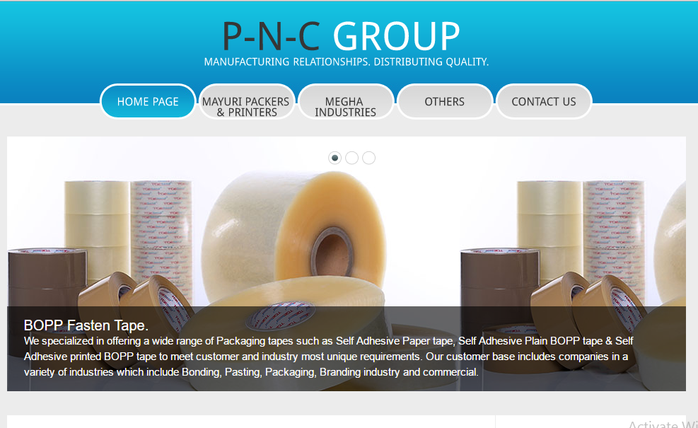

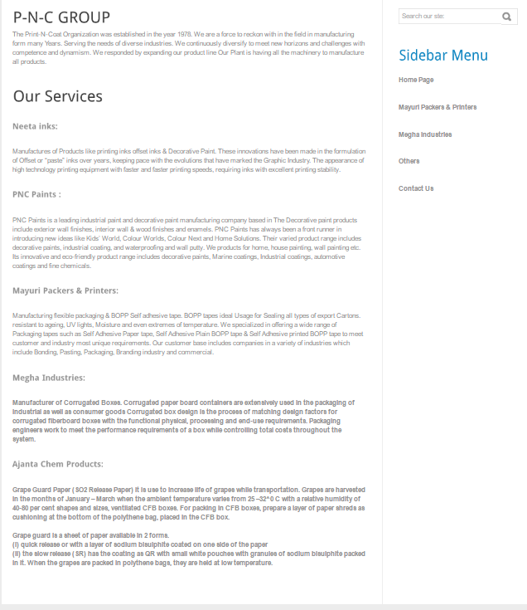

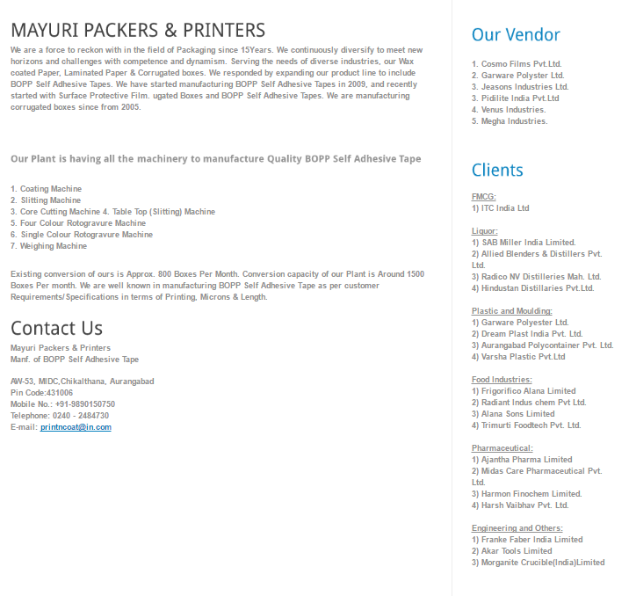

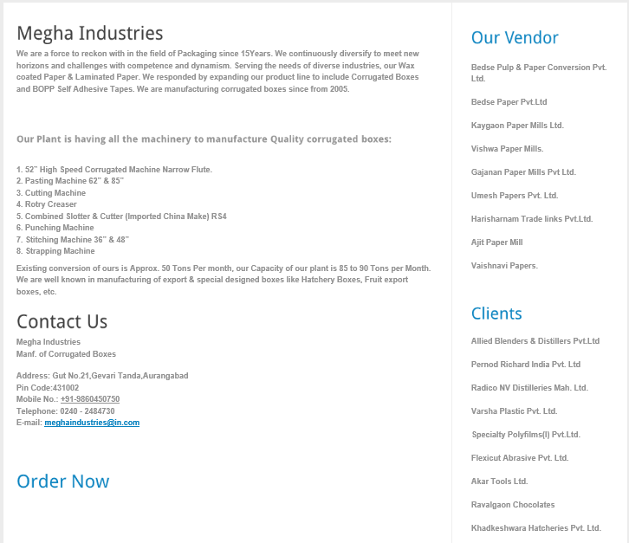

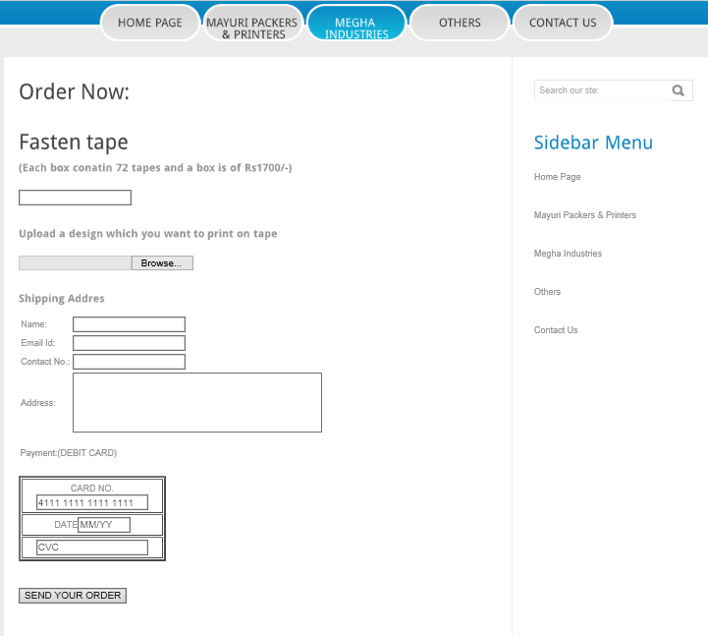

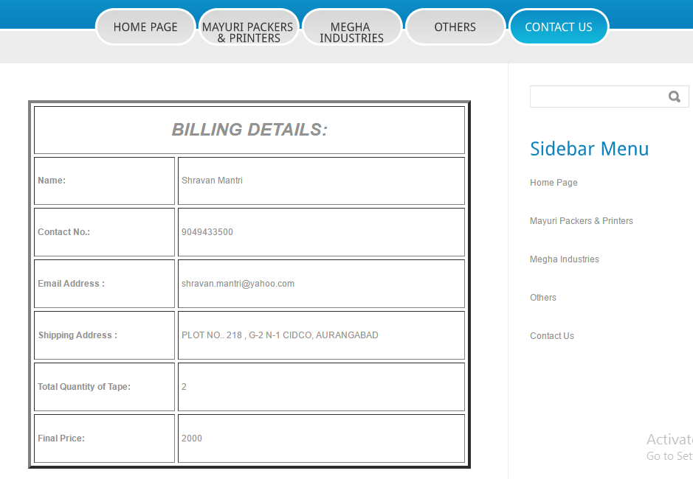
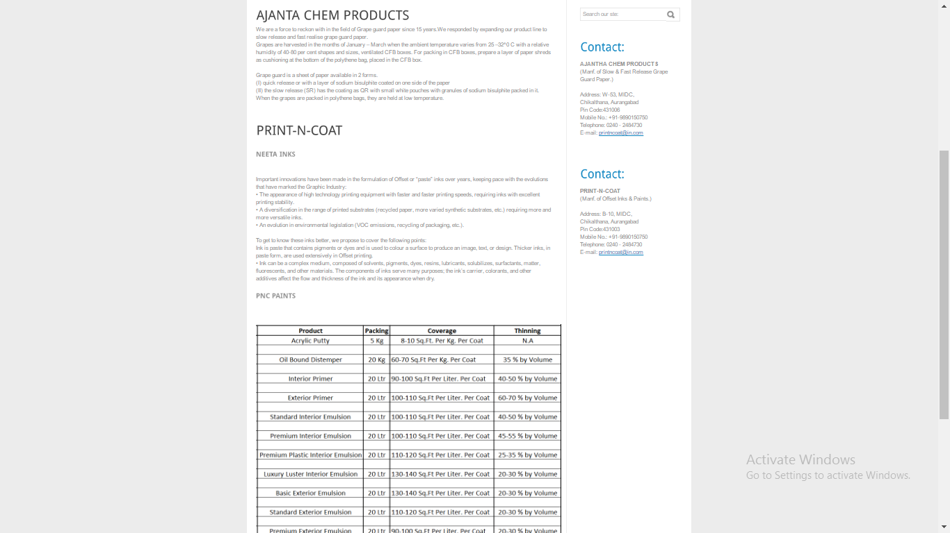
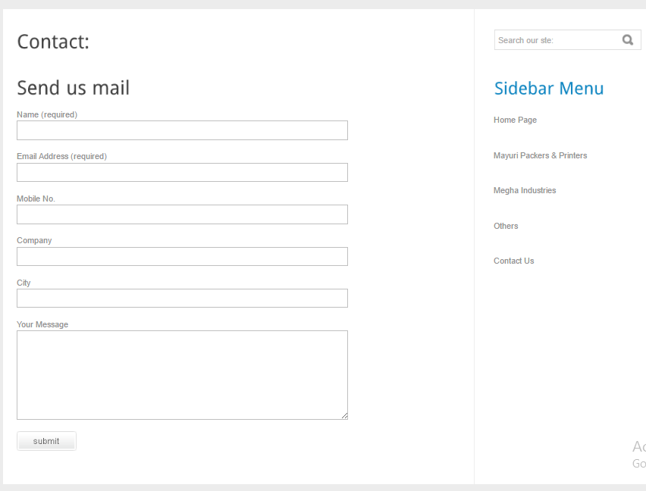

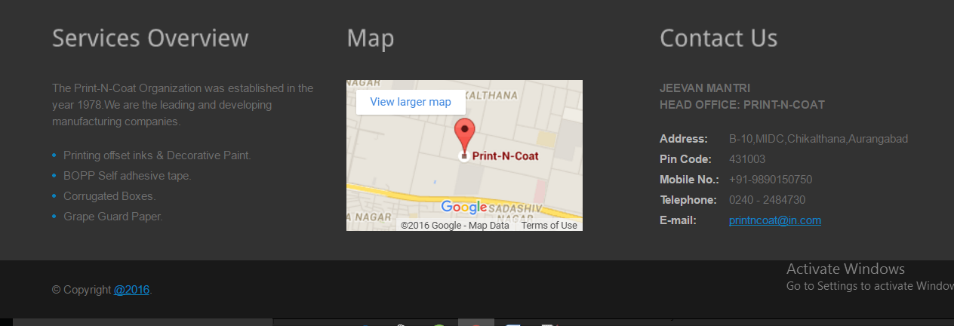

5.8 Test cases & Report
5.8.1 Types of Testing
5.8.1.1 White Box Testing
5.8.1.2 Black Box Testing
5.8.2 Test Cases
5.8.3Test Report
5.8.4 Testing & Result
5.9 Print out of report
6. Documentation & Installation
  - User Manual with Installation procedure
- System Maintenance
7.1 Maintenance
- Future Enhancements
- Limitations
- Conclusion
The P-N-C GROUP will be useful for people who want of manufacturing products. The site enables to browse through detail information about the products. Through this website you can order your BOPP tape with the brand name you want and there is a contact page through which you can contact our company for any query. Thus basically P-N-C Group acts as a platform for their growth in industrial area and spread it wide our company slogan “MANUFACTURING RELATIONSHIP. DISTRIBUTING QUALITY”. Our website has more or less achieved our goals. Thus, we have successfully planned and implemented the website with great effort and team work.

- BIBLIOGRAPHY
Websites

- www.w3schools.com
- www.youtube.com

12 Glossary of terms

